**Advance Excel Assignment 4**

**1. To use the ribbon commands, what menu and grouping of commands will you?**

**find the Insert and Delete command?**

**Ans**-The Ribbon is Excel’s command menu interface. It organizes commonly used actions together in an intuitive and visual way. These are the main parts of the Ribbon.

1.Tabs organize related groups of commands together.

2.Groups organize related commands together.

3.Command Buttons allows you to perform actions or open menus with further related actions.

4.Command Menu some command buttons will have a small down arrow located to the right or below the button. This indicates that a menu is available with sub-commands under the command button.

5.Dialog Box certain groups in the ribbon will contain a small icon in the lower right-hand corner that will launch a dialog box with further options available.

6.Pin or Unpin Toggle allows you to remove the ribbon from view to create more workbook space.

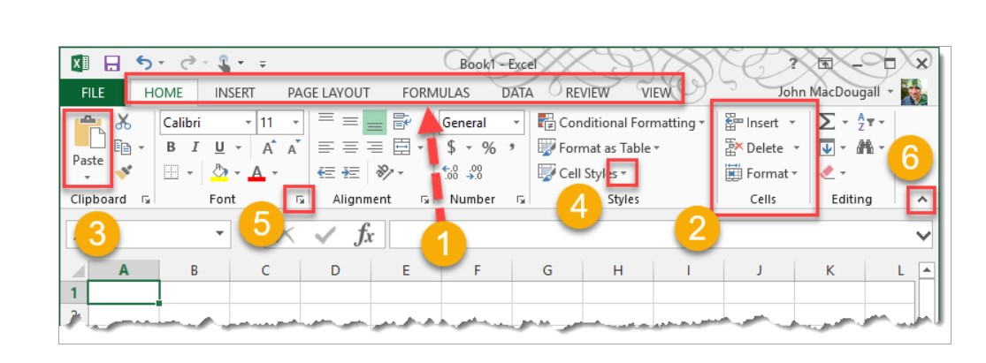

The insert, delete and format commands are present under insert group of home tab.

1.In Microsoft Office Excel, to insert a column or row, we follow the following steps:

2.We select any desired row or column, after which we go to Hobe tab. In Home tab, we go to Insert. Here, we select Insert Sheet Columns or Insert Sheet Rows.

3.In Microsoft Office Excel, to delete a column or row, we follow the following steps:

4.We select any desired row or column, after which we go to Hobe tab. In Home tab, we go to Insert. Here, we select Delete Sheet Columns or Delete Sheet Rows.

Hence, The insert, delete and format commands are present under insert group of home tab.

So, the Insert and the Delete buttons are part of the Cells group. This group of the home Tab ribbon holds the sixth position. Hence, as discussed earlier in the posts, like the Styles group; the buttons in the Cells-group also have Drop down list menu.

**2. If you set a row height or column width to 0 (zero), what happens to the row and**

**column?**

**Ans**-If I set a row height or column width to 0 (zero), then cell size become too small and its hide from the excel worksheet

shown in the pictures:

**3. Is there a need to change the height and width in a cell? Why?**

**Ans**-It is necessary to change width and height in excel to fit the data. Excel by default provide equal width and height with respect to columns and rows. Whenever we enter a lengthy data, few characters will get displayed and other will be present inside the cell but will be hidden to the user

Excel by default provide equal width and height with respect to columns and rows. Whenever we enter a lengthy data, few characters will get displayed and other will be present inside the cell but will be hidden to the user. It is necessary to change the rows and columns height and width to have a good presentation in excel. Few other cells width and height needs to be reduced so that it represents a smaller amount of data such as Gender which accepts ‘F’ or ‘M’.

So we can do- Select the column or columns that you want to change. On the Home tab, in the Cells group, click Format. Under Cell Size, click Column Width. ... Tip: To quickly set the width of a single column, right-click the selected column, click Column Width, type the value that you want, and then click OK.

**4. What is the keyboard shortcut to unhide rows?**

**Ans**-Ctrl + Shift + 9 is the keyboard shortcut to unhide rows.

**5. How to hide rows containing blank cells?**

**Ans**-1. Select the range that contains empty cells you want to hide.

2.On the Home tab, in the Editing group, click Find & Select > Go to Special.

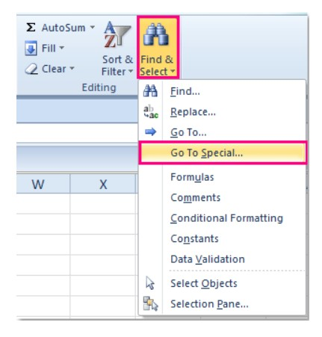

3.In the Go to Special dialog box, select the Blanks radio button, and click OK.

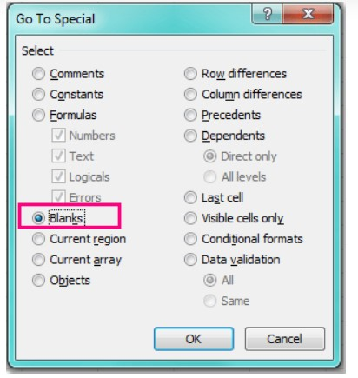

4.All the blank cells in the selection have been selected, see screenshot:

5. Then you can press Ctrl + 9 keys together to hide the rows which have blank cells.

**6. What are the steps to hide the duplicate values using conditional formatting in**

**excel?**

**Ans**-Supposing we have a range of values as below screenshot shown. For hiding all duplicates including the first one in Excel, as follows.

1.Select the range you want to hide duplicates. Here I select range A1:F11.

2. Then click Conditional Formatting > Highlight Cells Rules > **Duplicate Values** under **Home**tab. See screenshot.

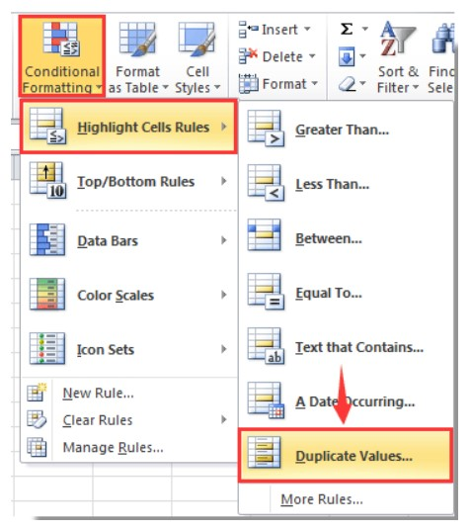

3. In the Duplicate Values dialog box, select Custom Format in the values with drop-down list, and then click the OK button.

4. In the Format Cells dialog box, go to the Font tab, and in the Colour drop-down list, choose a font Colour which matches the background Colour of your selected range cell. And finally click the OK button. See screenshot:

5. When it returns to the Duplicate Values dialog box, click the OK button.

Now all duplicate records in selected columns are hidden immediately.

